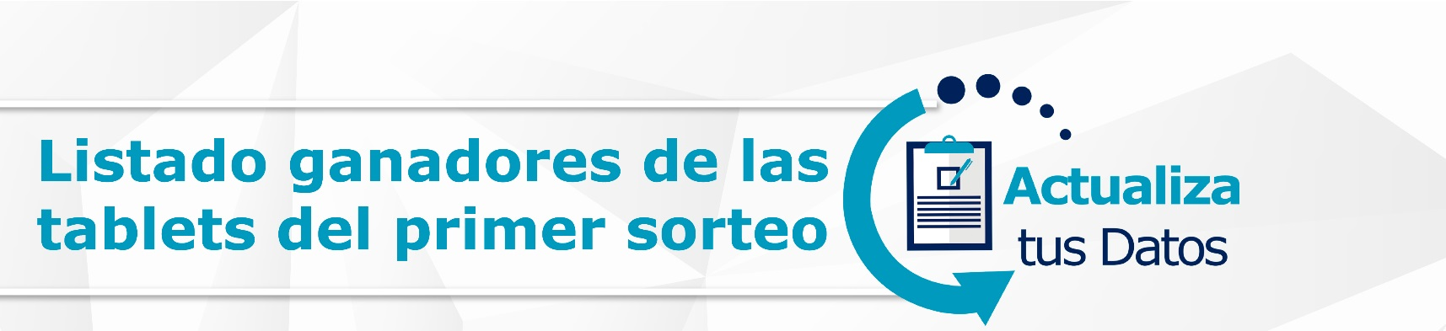

NIC | PREMIO | CIUDAD | OFICINA
8529266 | TABLET | CONCEPCION DE LA VEGA | 2337- LA VEGA
8837472 | TABLET | CONCEPCION DE LA VEGA | 2337- LA VEGA
8306986 | TABLET | CONSTANZA | 2339- CONSTANZA
3288544 | TABLET | COTUI | 2447- COTUI
3270857 | TABLET | EL FACTOR | 2449- NAGUA
8709678 | TABLET | GASPAR HERNANDEZ | 2252- G. HDEZ.
8567415 | TABLET | JAYACO (D.M.) | 2358 JIMA SABANA PTO
8658482 | TABLET | MAO | 2542- VALVERDE MAO
8865002 | TABLET | MAO | 2542- VALVERDE MAO
7174627 | TABLET | PARTIDO | 2564 - PARTIDO
3179961 | TABLET | PIMENTEL | 2448- PIMENTEL
8591522 | TABLET | SAN FELIPE DE PUERTO PLATA | 2211-SAN MARCOS
7098520 | TABLET | SAN FERNANDO DE MONTE CRISTI | 2544- MONTECRISTI
7177171 | TABLET | SAN FERNANDO DE MONTE CRISTI | 2544- MONTECRISTI
8494431 | TABLET | SAN FRANCISCO DE MACORIS | 2457-S. FRANCISCO II
8850963 | TABLET | SAN FRANCISCO DE MACORIS | 2446- SAN FRANCISCO
2197374 | TABLET | SAN FRANCISCO DE MACORIS | 2457-S. FRANCISCO II
2203228 | TABLET | SAN FRANCISCO DE MACORIS | 2457-S. FRANCISCO II
8882185 | TABLET | SANTIAGO DE LOS CABALLEROS | 2148 REPPERALTA
8732297 | TABLET | SANTIAGO DE LOS CABALLEROS | 2137- GURABO
8770467 | TABLET | SANTIAGO DE LOS CABALLEROS | 2133- SANTIAGO
8725929 | TABLET | SANTIAGO DE LOS CABALLEROS | 2130- SANTIAGO
8237150 | TABLET | SANTIAGO DE LOS CABALLEROS | 2130- SANTIAGO
8857390 | TABLET | SANTIAGO DE LOS CABALLEROS | 2148 REPPERALTA
8248882 | TABLET | SANTIAGO DE LOS CABALLEROS | 2113-LA OTRA BANDA
8523557 | TABLET | SOSUA | 2251- SOSUA
8605964 | TABLET | TIREO (D.M.) | 2346 - TIREO
8642065 | TABLET | VILLA MAGANTE (D.M.) | 2252- G. HDEZ.
7072835 | TABLET | VILLA MONTELLANO (D.M.) | 2243-MONTELLANOS

